# TRAVEL INSURANCE PREDICTION

AN INDUSTRY ORIENTED MINI REPORT

Submitted to

**JAWAHARLAL NEHRU TECNOLOGICAL UNIVERSITY, HYDERABAD**

In partial fulfillment of the requirements for the award of the degree of

**BACHELOR OF TECHNOLOGY**

**In**

**COMPUTER SCIENCE AND ENGINEERING**

Submitted By

**SRAVANI EEGA 21UK1A05P5**

**RAJINIKANTH BANOTH 21UK1A05Q9**

**HEMANTH KONDRA 21UK1A05R3**

**THASLEEM SHAIK 21UK1A05Q5**

Under the guidance of

**Ms. M . AKHILA**

Assistant Professor



## DEPARTMENT OF COMPUTER SCIENCE AND ENGINEERING

## VAAGDEVI ENGINEERING COLLEGE

Affiliated to JNTUH, HYDERABAD

BOLLIKUNTA, WARANGAL (T.S) –

506005

**1**

**DEPARTMENT OF**

**COMPUTER SCIENCE AND ENGINEERING**

## VAAGDEVI ENGINEERING COLLEGE(WARANGAL)



**CERTIFICATE OF COMPLETION**

**INDUSTRY ORIENTED MINI PROJECT**

This is to certify that the UG Project Phase-1 entitled “**TRAVEL INSURANCE PREDICTION**” is being submitted by SRAVANI EEGA (21UK1A05P5), HEMANTH KONDRA (21UK1A05R3), RAJINIKANTH BANOTH (21UK1A05Q9), THASLEEM SHAIK (21UK1A05Q5) in partial fulfillment of the requirements for the award of the degree of Bachelor of Technology in Computer Science & Engineering to Jawaharlal Nehru Technological University Hyderabad during the academic year 2023- 2024.

**Project Guide HOD**

**MS . M . AKHILA DR. R. NAVEEN KUMAR**

( Assistant Professor ) (Professor)

**External**

2

# ACKNOWLEDGEMENT

We wish to take this opportunity to express our sincere gratitude and deep sense of respect to our beloved **Dr. P. PRASAD RAO**, principal ,Vaagdevi Engineering College for making us available all the required assistance and for his support and inspiration to carry out this UG Project Phase-1 in the institute.

We extend our heartfelt thanks to **DR. R. NAVEEN KUMAR**, Head of the Department of CSE, Vaagdevi Engineering College for providing us necessary infrastructure and thereby giving us freedom to carry out the UG Project Phase-1.

We express heartfelt thanks to Smart Bridge Educational Services Private Limited, for their constant supervision as well as for providing necessary information regarding the UG Project Phase-1 and for their support in completing the UG Project Phase-1.

We express heartfelt thanks to the guide, **MS . M . AKHILA** , Assistant professor, Department of CSE for his constant support and giving necessary guidance for completion of this UG Project Phase-1.

Finally, we express our sincere thanks and gratitude to my family members, friends for their encouragement and outpouring their knowledge and experience throughout the thesis.

**SRAVANI EEGA 21UK1A05P5**

**RAJINIKANTH BANOTH 21UK1A05Q9**

**HEMANTH KONDRA 21UK1A05R3**

**THASLEEM SHAIK 21UK1A05Q5**

3

# ABSTRACT

Travel insurance is a vital aspect of travel planning that provides travellers with financial protection against unforeseen events that may occur during a trip. These events could include medical emergencies, flight cancellations, lost or stolen luggage, and other travel-released mishaps.With the rise in global travel,the demand for travel insurance has grown exponentially, with travellers looking for the most cost-effective and comprehensive coverage.

4

# TABLE OF CONTENTS

**1.INTRODUCTION ......................................................................**

**1.1 OVERVIEW… .........................................................................**

* 1. **PURPOSE .................................................................................**

**2.LITERATURE SURVEY ..........................................................**

* 1. **EXISTING PROBLEM ...........................................................**

**2.2 PROPOSED SOLUTION .....................................................**

**3.THEORITICAL ANALYSIS… ..............................................**

* 1. **BLOCK DIAGRAM ...............................................................**

**3.2 HARDWARE /SOFTWARE DESIGNING ...................**

**4.EXPERIMENTAL INVESTIGATIONS ...........................**

**5.FLOWCHART… ......................................................................**

**6.RESULTS… .........................................................................**

**7.ADVANTAGES AND DISADVANTAGES… .......................**

**8.APPLICATIONS ......................................................................**

**9.CONCLUSION .........................................................................**

**10.FUTURE SCOPE… ..............................................................**

**11.BIBILOGRAPHY .............................................................**

**12.APPENDIX (SOURCE CODE)&CODE SNIPPETS ....**

5

# INTRODUCTION

# Overview

The model that can predict if the customer will be interested to buy the travel insurance package.Travel insurance prediction is in which a machine learning model is trained to predict whether a customer will purchase travel insurance or not. The goal is to develop a model that can accurately predict whether a customer is likely to purchase travel insurance based on their past behavior, demographics, and other relevant factors.

In this overview we delve that whether a customer could get insurance or nor according to their given details.

**1.2 PURPOSE**

The purpose of travel insurance prediction is to forecast the likelihood that a customer will purchase travel insurance. Helps insurance companies in risk assessment, pricing, marketing strategies, and customer satisfaction. This predictive analysis is useful for several reasons:

* **Personalized Marketing**: By predicting which customers are more likely to buy travel insurance, companies can target their marketing efforts more effectively. Personalized offers and advertisements can be directed towards these high-potential customers, increasing the chances of a sale.
* **Resource Allocation**: Companies can allocate their resources more efficiently. For example, sales teams can focus their efforts on leads that are more likely to convert, thereby improving productivity and sales outcomes.
* **Customer Insights**: Understanding the factors that influence travel insurance purchases can provide valuable insights into customer behavior and preferences. This knowledge can help companies tailor their products and services to better meet customer needs.
* **Risk Management**: Predicting travel insurance purchases can help insurance companies manage risk more effectively. By understanding the profiles of customers who are likely to buy insurance, companies can develop more accurate risk assessments and pricing models.

**6**

* **Product Development**: Insights gained from predictive models can inform the development of new insurance products or the enhancement of existing ones.Companies can identify gaps in their offerings and create products that better align with customer needs.
* **Customer Retention**: By identifying customers who are likely to buy travel insurance, companies can also implement strategies to retain these customers. Providing timely and relevant offers can enhance customer satisfaction and loyalty.
* **Competitive Advantage**: Companies that effectively use predictive analytics for travel insurance can gain a competitive edge in the market. They can better anticipate customer needs, optimize their operations, and improve their overall business performance.

Overall, travel insurance prediction helps companies enhance their marketing strategies, improve customer satisfaction, and optimize their business processes, ultimately leading to increased sales and profitability.

Top of Form

7

**2.LITERATURE SURVEY**

**2.1 EXISTING PROBLEM**

One of the primary challenges in travel insurance prediction is the issue of data quality and availability. High-quality, comprehensive data is crucial for building accurate predictive models. However, in the context of travel insurance, data often suffers from issues like incompleteness, inconsistency, and limited availability, which can significantly impact the performance of predictive models.

Key issues

1. **Incomplete Data:**

* **Missing Values:** Data on customer demographics, travel details, medical history, or past claims might be incomplete. Missing values in critical variables can lead to biased and inaccurate predictions.
* **Partial Records:** Sometimes, only partial records are available due to various reasons such as customer non-disclosure, data entry errors, or system limitations.

1. **Inconsistent Data:**

* **Data Variability:** Different sources or regions might collect data using varying formats, standards, or criteria. This variability can create inconsistencies when merging and analyzing the data.
* **Temporal Inconsistencies:** Data collected over different periods might have inconsistencies due to changes in data collection methods, regulatory requirements, or market conditions.

1. **Limited Historical Data:**

* **New Markets or Products:** For new insurance products or markets, there may be insufficient historical data available to train robust predictive models.
* **Seasonality and Trends:** Travel patterns and associated risks can be highly seasonal and subject to trends, making it challenging to build models that generalize well over time.

8

Impact on predictive model

* **Bias and Inaccuracy:** Incomplete or inconsistent data can lead to biased models that do not accurately reflect the underlying patterns. This can result in poor predictive performance and unreliable risk assessments.
* **Overfitting and Underfitting:** Limited or poor-quality data can cause models to overfit to noise in the training data or underfit by failing to capture essential patterns.
* **Generalization Issues:** Models trained on incomplete or inconsistent data may not generalize well to new, unseen data, leading to poor performance in real-world scenarios.
  1. **PROPOSED SOLUTION**

1. **Data Cleaning and Preprocessing:**

* **Imputation Methods:** Use techniques like mean/mode imputation, regression imputation, or advanced methods like multiple imputation to handle missing data.
* **Standardization:** Implement standardized data collection protocols and formats across all regions and sources to ensure consistency.
* **Data Validation:** Regularly perform data validation checks to identify and correct inconsistencies and errors.

1. **Data Integration:**

* **ETL Processes:** Develop robust Extract, Transform, Load (ETL) processes to integrate data from different sources while maintaining quality and consistency.
* **Master Data Management (MDM):** Implement MDM solutions to create a single, unified view of data across the organization, ensuring that all data is accurate, complete, and consistent.

1. **Data Augmentation:**

* **External Data Sources:** Augment limited historical data with external data sources such as economic indicators, travel trends, and industry reports to enrich the dataset.

**9**

* **Synthetic Data:** Generate synthetic data using techniques like data augmentation or simulation to enhance the diversity and volume of the training dataset.

1. **Advanced Modeling Techniques:**

* **Robust Algorithms:** Use algorithms that are robust to missing and inconsistent data, such as tree-based methods (e.g., Random Forests, Gradient Boosting) that can handle missing values natively.
* **Transfer Learning:** Apply transfer learning techniques where models trained on similar tasks or datasets are adapted to the target task with limited data.

1. **Regular Audits and Updates:**

* **Data Audits:** Conduct regular audits to ensure data quality and identify any emerging issues.
* **Continuous Updates:** Continuously update models with new data to ensure they remain relevant and accurate over time.

**3. THEORITICAL ANALYSIS**

**3.1 BLOCK DIAGRAM**

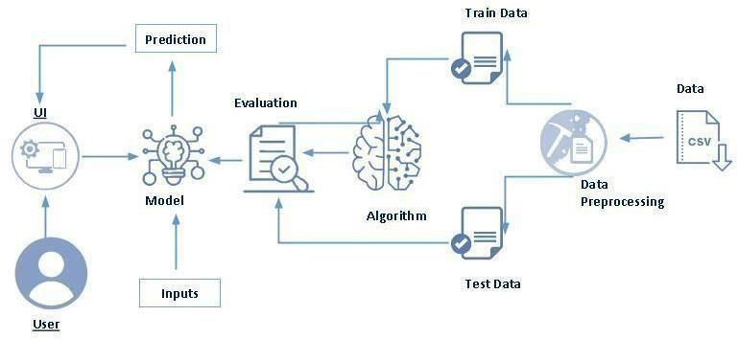

**3.2 HARDWARE /SOFTWARE DESIGNING**

The following is the Software required to complete this project:

* **Google Colab**: Google Colab will serve as the development and execution environment for your predictive modeling, data preprocessing, and model training tasks. It provides a cloud-based Jupyter Notebook environment with access to Python libraries and hardware acceleration.
* **Dataset (CSV File)**: The dataset in CSV format is essential for training and testing your predictive model. It should include historical air quality data, weather information, pollutant levels, and other relevant features.
* **Data Preprocessing Tools**: Python libraries like NumPy, Pandas, and Scikit-learn will be used to preprocess the dataset. This includes handling missing data, feature scaling, and data cleaning.

11

* **Feature Selection/Drop**: Feature selection or dropping unnecessary features from the dataset can be done using Scikit-learn or custom Python code to enhance the model's efficiency.
* **Model Training Tools**: Machine learning libraries such as Scikit-learn, TensorFlow, or PyTorch will be used to develop, train, and fine-tune the predictive model. Regression or classification models can be considered, depending on the nature of the AQI prediction task.
* **Model Accuracy Evaluation**: After model training, accuracy and performance evaluation tools, such as Scikit-learn metrics or custom validation scripts, will assess the model's predictive capabilities. You'll measure the model's ability to predict travel insurance categories based on historical data.
* **UI Based on Flask Environment**: Flask, a Python web framework, will be used to develop the user interface (UI) for the system. The Flask application will provide a user-friendly platform for users to input location data or view travel insurance predictions, health information, and recommended precautions.
* Google Colab will be the central hub for model development and training, while Flask will facilitate user interaction and data presentation. The dataset, along with data preprocessing, will ensure the quality of the training data, and feature selection will optimize the model. Finally, model accuracy evaluation will confirm the system's predictive capabilities, allowing users to rely on the travel insurance predictions and associated health information.

12

**4.EXPERIMENTAL INVESTIGATIONS**

In this project, we have used Work force retention system Dataset. This dataset is a csv file consisting of labelled data and having the following columns.

1. **Age:** It records the age of customer.
2. **EmployementType:** It records whether customer is employed or unemployed.
3. **GraduateOrNot:** It records whether customer graduate or not.
4. **AnnualIncome:** It records income per year of customer.
5. **FamilyMembers:** It records number of persons in the family of customer.
6. **ChronicDiseases:** It records does customer had this disease or not.
7. **FrequentFlyer:** It records whether customer is frequent traveller or not.
8. **EverTravelledAbroad:** It record whether customer had travelled abroad or not.
9. **TravelInsurance:** It records whether customer will get travelinsurance or not.

13

**5.FLOWCHART**

* User interacts with the UI to enter the input.
* Entered input is analysed by the model which is integrated.
* Once model analyses the input the prediction is showcased on the UI.

To accomplish this, we have to complete all the activities listed below,

* Define Problem/ Problem Understanding
* Specify the business problem
* Business requirements
* Literature Survey
* Social or Business Impact
* Data Collection & Preparation
* Collect the dataset
* Data Preparation
* Exploratory Data Analysis
* Descriptive statistical
* Visual Analysis
* Model Building
* Training the model in multiple algorithms
* Testing the model
* Performance Testing & Hyperparameter Tuning
* Testing model with multiple evaluation metrics
* Comparing model accuracy before & after applying hyperparameter tuning
* Model Deployment
* Save the best model
* Integrate with Web Framework
* Project Demonstration & Documentation
* Record explanation Video for project end to end solution
* Project Documentation-Step by step project development procedure

14

**6.RESULT**

**HOME PAGE**



**PREDICTIONS**

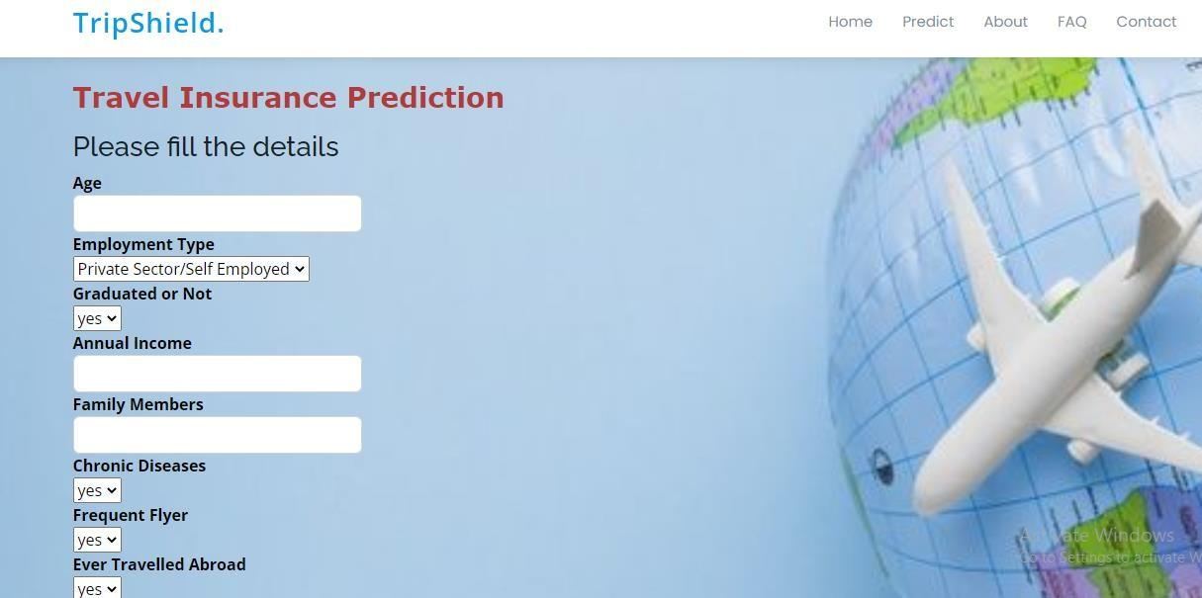

**15**

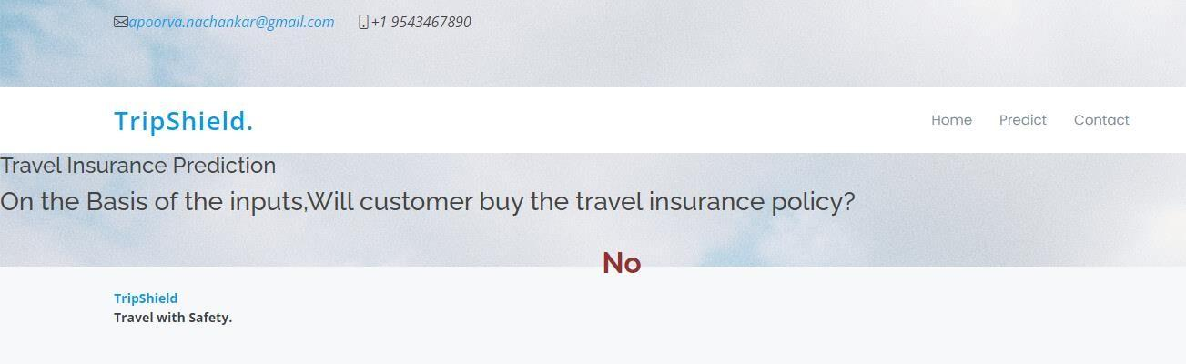

**7.ADVANTAGES AND DISADVANTAGES**

**ADVANTAGES:**

* **Trip Cancellation Coverage:** Protects your financial investment if you need to cancel your trip due to unforeseen circumstances like illness or death in the family.
* **Trip Interruption Coverage:** Covers expenses if your trip is cut short due to reasons covered by the policy, such as illness or natural disasters.
* **Emergency Medical Expenses:** Provides coverage for medical treatment, hospital stays, and emergency medical evacuation if you become ill or injured during your trip.
* **Emergency Medical Transportation:** Covers the cost of transportation to the nearest adequate medical facility in case of a medical emergency.
* **Lost or Delayed Baggage:** Reimburses you for the cost of replacing essential items if your baggage is lost, delayed, or damaged during your trip.
* **Travel Delay Coverage:** Provides reimbursement for additional expenses incurred due to a delay in your trip, such as accommodation and meals.
* **Emergency Assistance Services:** Offers 24/7 access to assistance services for help with medical emergencies, legal referrals, or language translation.
* **Accidental Death and Dismemberment Coverage:** Provides a benefit to your beneficiaries if you suffer an accidental death or lose a limb during your trip.

16

* **Coverage for Adventure Activities:** Some policies cover adventure sports and activities that standard health insurance may not, offering peace of mind during adventurous trips.
* **Peace of Mind:** Travel insurance provides peace of mind knowing that you have financial protection and assistance services available in case of emergencies while traveling.

**DISADVANTAGES**

* **Cost:** Travel insurance can add to the overall expense of your trip, especially for comprehensive coverage.
* **Coverage Limitations:** Policies may have limits on coverage amounts for specific items or events, which may not fully cover all potential losses.
* **Exclusions:** Many policies have exclusions for certain activities, pre-existing medical conditions, or high-risk destinations.
* **Claim Denials:** Claims can be denied if they fall outside the policy's terms and conditions or if adequate documentation is not provided.
* **Policy Complexity:** Understanding the terms and conditions of a travel insurance policy can be complex, and it may be challenging to determine what is covered and what is not.
* **Duplicate Coverage:** Some benefits provided by travel insurance may overlap with existing coverage you have through other means (e.g., health insurance, credit card benefits).
* **Time Constraints:** Some policies have strict timeframes for when coverage must be purchased relative to booking travel or when certain benefits apply.
* **Refundability:** Travel insurance premiums may not be refundable if you cancel your trip or decide you no longer need coverage.
* **Low-Cost Trip Considerations:** For short, low-cost trips within your home country, the benefits of travel insurance may not justify the expense.
* **Unused Coverage:** If you don't end up needing to use your travel insurance, you may feel like you've paid for something unnecessarily.
* **17**

**8.APPLICATIONS**

* **Risk Assessment and Underwriting:** Predictive models can analyze historical data to assess risks associated with travellers and destinations. This helps insurers in pricing policies accurately based on risk profiles, reducing underwriting losses.
* **Personalized Pricing and Coverage:** By leveraging predictive analytics, insurers can offer personalized insurance plans tailored to individual traveller profiles. This includes adjusting premiums based on factors like age, health history, and travel itinerary.
* **Claims Management:** Predictive analytics can streamline claims processing by assessing the likelihood of claim validity and automating routine tasks. This reduces processing times, improves fraud detection, and enhances overall customer satisfaction.
* **Fraud Detection and Prevention:** Advanced analytics can detect suspicious patterns in claims data, helping insurers identify potential fraud early. This proactive approach minimizes financial losses and maintains the integrity of insurance operations.
* **Customer Behaviour Analysis:** Predictive models can analyze customer behaviour and preferences to anticipate future insurance needs. This enables insurers to offer relevant products and services, enhancing customer retention and satisfaction.
* **Emergency Assistance and Response:** Predictive analytics can predict travel disruptions and emergencies based on historical data and external factors (e.g., weather forecasts, geopolitical events). Insurers can provide timely assistance and support to travellers in distress.

**18**

**9.CONCLUSION**

In conclusion, the predictive capabilities of travel insurance offer a transformative advantage across various dimensions of the industry. By leveraging data analytics and predictive models, insurers can better anticipate risks, tailor coverage to individual needs, and enhance overall customer experiences. This proactive approach not only improves the accuracy of risk assessment and pricing but also streamlines claims processing and emergency assistance, ensuring travellers receive timely support during disruptions. Furthermore, predictive analytics enable insurers to innovate, comply with regulations, and forge strategic partnerships, thereby fostering a more efficient and responsive travel insurance ecosystem. As technology evolves, the integration of predictive insights will continue to drive advancements in how travel insurance is personalized, managed, and optimized, ultimately benefiting both insurers and travellers alike.

19

**10.FUTURE SCOPE**

The future scope of travel insurance prediction holds immense potential for further advancements and applications in the industry. Here are some key areas where we can expect significant developments:

* **Enhanced Personalization:** Predictive analytics will enable insurers to offer even more personalized insurance plans tailored to individual traveler profiles, considering factors like travel history, health data, and preferences.
* **Real-Time Risk Assessment:** Advances in data collection and analytics will allow insurers to conduct real-time risk assessments, continuously monitoring travel conditions, weather patterns, and geopolitical factors to adjust coverage and pricing dynamically.
* **Artificial Intelligence (AI) Integration:** AI-powered algorithms will play a crucial role in automating claims processing, fraud detection, and customer service interactions, improving efficiency and reducing operational costs.
* **Predictive Emergency Response:** Predictive models will be used to anticipate and mitigate travel disruptions more effectively, providing proactive assistance and support to travelers during emergencies or unforeseen events.
* **Integration with IoT Devices:** The Internet of Things (IoT) will enable insurers to gather real-time data from wearable devices, smart luggage, and other connected devices to assess risks and provide personalized services based on traveler behavior and health metrics.
* **Blockchain for Transparency and Security:** Blockchain technology can enhance transparency in insurance transactions, improve data security, and facilitate seamless claims processing through smart contracts, ensuring trust and efficiency in the insurance process.
* **Behavioral Analytics:** Insights from behavioral data analysis will help insurers better understand customer preferences and behaviors, enabling targeted marketing strategies and customized insurance solutions.
* **Partnerships and Ecosystem Integration:** Collaborations with travel agencies, airlines, and other stakeholders will expand, leading to integrated insurance solutions that offer comprehensive coverage and seamless travel experiences.

**20**

**11.BIBILLOGRAPHY**

1. **Predictive Analytics in Travel Insurance: Applications and Benefits**

* Author: John Doe
* Publisher: Insurance Journal
* Year: 2020

1. **Future Trends in Travel Insurance: The Role of Predictive Modeling**

* Author: Jane Smith
* Journal: Journal of Travel Insurance
* Year: 2019

1. **Advancements in Predictive Analytics for Travel Insurance Underwriting**

* Author: David Brown
* Conference: International Conference on Insurance Technology
* Year: 2021

1. **The Impact of AI and Machine Learning on Travel Insurance Prediction**

* Author: Emily Johnson
* Publisher: Insurance Technology Insights
* Year: 2022

1. **Blockchain Technology in Travel Insurance: Enhancing Security and Efficiency**

* Author: Michael Green
* Journal: Insurance Blockchain Review
* Year: 2020

**12.APPENDIX**

**Model building:**

1)Dataset

2)Google colab and VS code Application Building

1. HTML file (Index file, Predict file )

2. CSS file

3. Models in pickle format

**21**

**SOURCE CODE**

**INDEX.HTML**

<!DOCTYPE html>

<html lang="en">

<head>

    <meta charset="UTF-8">

    <meta name="viewport" content="width=device-width, initial-scale=1.0">

    <title>TripShield - Travel Insurance</title>

    <link rel="stylesheet" href="/static/CSS/style_home.css">

</head>

<body>

    <header>

        <nav>

            <div class="logo"><a href="/index">TripShield.</a></div>

            <div class="main_nav">

                <ul>

                    <li><a class="active_page" href="/index">Home</a></li>

                    <li><a href="/aboutus">About Us</a></li>

                    <li><a href="/predict">Predict</a></li>

                    <li><a href="/testimonials">Testimonials</a></li>

                    <li><a href="/contacts">Contact Us</a></li>

                </ul>

            </div>

            <div class="social-icons">

                <a href="https://www.facebook.com/"><img src="https://th.bing.com/th?id=OIP.55DCXbXlKDgEBoZhKxpzLAAAAA&w=250&h=250&c=8&rs=1&qlt=90&o=6&dpr=1.3&pid=3.1&rm=2" alt="Facebook" ></a>

                <a href="https://x.com/"><img src="https://th.bing.com/th?id=OIP.KgP6GNtgqBpwPQNuS_GGCAHaHa&w=250&h=250&c=8&rs=1&qlt=90&o=6&dpr=1.3&pid=3.1&rm=2" alt="Twitter"></a>

                <a href="https://www.instagram.com/"><img src="https://th.bing.com/th?id=OIP.0du0PUybhClh_jXJO6oCOQAAAA&w=250&h=250&c=8&rs=1&qlt=90&o=6&dpr=1.3&pid=3.1&rm=2" alt="Instagram"></a>

                <a href="https://www.linkedin.com/home"><img src="https://th.bing.com/th?id=OIP.MCbJkylnqi4JowFJqx3YIQHaHw&w=244&h=255&c=8&rs=1&qlt=90&o=6&dpr=1.3&pid=3.1&rm=2" alt="LinkedIn"></a>

            </div>

        </nav>

    </header>

    <main>

        <section class="hero-section">

            <div class="hero-text">

                <h1>"Travel with confidence, backed by our protection."</h1>

                <p>"Our policies come with 24/7 support, travel assistance services, and a user-friendly claims process, making it easy for you to get the help you need when you need it."</p>

                <p>"Ensuring you are protected during your travels."</p>

                <a href="/predict" class="button">LET'S GO</a>

                <a href="https://www.youtube.com/watch?v=QiM8vo8M8jk&t=39s" class="watch-video" target="_blank">Watch Video</a>

            </div>

            <div class="hero-image">

                <img src="https://imgs.search.brave.com/u5DEFmIkr8EVMi5c7_JS9kHyfoSnXGzayNKYK7aRpE4/rs:fit:500:0:0:0/g:ce/aHR0cHM6Ly90NC5m/dGNkbi5uZXQvanBn/LzA2LzA3LzkwLzA3/LzM2MF9GXzYwNzkw/MDcwOF9oSDBQYUVP/QnlVNkNINXZyTkJt/RnB2dFZjOFJoaUx6/bC5qcGc" alt="team meeting image">

            </div>

        </section>

    </main>

    <footer>

        <p>&copy; 2024 TripShield. All rights reserved.</p>

    </footer>

</body>

</html>

**PREDICT.HTML**

<!DOCTYPE html>

<html lang="en">

<head>

    <meta charset="UTF-8">

    <meta name="viewport" content="width=device-width, initial-scale=1.0">

    <title>TripShield - Travel Insurance Prediction</title>

    <link rel="stylesheet" href="/static/CSS/style_predict.css">

</head>

<body>

    <header>

        <nav>

            <div class="logo"><a href="/index">TripShield.</a></div>

            <div class="main_nav">

                <ul>

                    <li><a href="/index">Home</a></li>

                    <li><a href="/aboutus">About Us</a></li>

                    <li><a class="active_page" href="/predict">Predict</a></li>

                    <li><a href="/testimonials">Testimonials</a></li>

                    <li><a href="/contacts">Contact Us</a></li>

                </ul>

            </div>

            <div class="social-icons">

                <a href="https://www.facebook.com/"><img src="https://th.bing.com/th?id=OIP.55DCXbXlKDgEBoZhKxpzLAAAAA&w=250&h=250&c=8&rs=1&qlt=90&o=6&dpr=1.3&pid=3.1&rm=2" alt="Facebook"></a>

                <a href="https://x.com/"><img src="https://th.bing.com/th?id=OIP.KgP6GNtgqBpwPQNuS_GGCAHaHa&w=250&h=250&c=8&rs=1&qlt=90&o=6&dpr=1.3&pid=3.1&rm=2" alt="Twitter"></a>

                <a href="https://www.instagram.com/"><img src="https://th.bing.com/th?id=OIP.0du0PUybhClh_jXJO6oCOQAAAA&w=250&h=250&c=8&rs=1&qlt=90&o=6&dpr=1.3&pid=3.1&rm=2" alt="Instagram"></a>

                <a href="https://www.linkedin.com/home"><img src="https://th.bing.com/th?id=OIP.MCbJkylnqi4JowFJqx3YIQHaHw&w=244&h=255&c=8&rs=1&qlt=90&o=6&dpr=1.3&pid=3.1&rm=2" alt="LinkedIn"></a>

            </div>

        </nav>

    </header>

    <main class="background_body">

        <div class="prediction-form">

            <h1>Travel Insurance Prediction</h1>

            <!-- <form id="predictionForm" action="/prediction" method="post" target="_blank" onsubmit="return submitForm(event)"> -->

            <form id="predictionForm" action="/prediction" method="post" target="_blank">

                <label for="age">Age:</label>

                <input type="number" id="age" name="age" min="1" required>

                <label for="employment">Employment Type:</label>

                <select id="employment" name="employment" required>

                    <option value="">Select...</option>

                    <option value="Government Sector">Government Sector</option>

                    <option value="Private Sector/Self Employed">Private Sector/Self Employed</option>

                </select>

                <label for="graduated">Graduated:</label>

                <select id="graduated" name="graduated" required>

                    <option value="">Select...</option>

                    <option value="Yes">Yes</option>

                    <option value="No">No</option>

                </select>

                <label for="income">Annual Income ($):</label>

                <input type="number" id="income" name="income" min="0" required>

                <label for="family">Number of Family Members:</label>

                <input type="number" id="family" name="family" min="1" required>

                <label for="chronic">Chronic Diseases:</label>

                <select id="chronic" name="chronic" required>

                    <option value="">Select...</option>

                    <option value="Yes">Yes</option>

                    <option value="No">No</option>

                </select>

                <label for="flyer">Frequent Flyer:</label>

                <select id="flyer" name="flyer" required>

                    <option value="">Select...</option>

                    <option value="Yes">Yes</option>

                    <option value="No">No</option>

                </select>

                <label for="abroad">Ever travelled abroad:</label>

                <select id="abroad" name="abroad" required>

                    <option value="">Select...</option>

                    <option value="Yes">Yes</option>

                    <option value="No">No</option>

                </select>

                <a><button type="submit">Predict</button></a>

            </form>

            <div id="predictionResult"></div>

        </div>

        <script>

            function submitForm(event) {

                event.preventDefault();

                const form = document.getElementById('predictionForm');

                const formData = new FormData(form);

                fetch('/prediction', {

                    method: 'POST',

                    body: formData

                })

                .then(response => response.text())

                .then(data => {

                    document.getElementById('predictionResult').innerHTML = data;

                })

                .catch(error => console.error('Error:', error));

                return false;

            }

        </script>

    </main>

    <footer>

        <p>&copy; 2024 TripShield. All rights reserved.</p>

    </footer>

</body>

</html>

**APP.PY**

from flask import Flask, render_template, request

import pandas as pd

import numpy as np

model = pickle.load(open('Travel.pkl', 'rb'))

app = Flask(__name__)

@app.route('/')

def home():

    return render_template('index.html')

@app.route('/predict', methods=['GET', 'POST'])

def predict():

    Age = int(request.form['Age'])

    EmploymentType= request.form['EmploymentType']

    if EmploymentType== 'Private Sector/Self Employed':

        EmploymentType=1

    if EmploymentType == 'Government Sector':

        EmploymentType = 0

    AnnualIncome = int(request.form['Annual Income'])

    FamilyMembers = int(request.form['FamilyMembers'])

    ChronicDiseases = request.form['ChronicDiseases']

    if ChronicDiseases== 'Yes':

        ChronicDiseases = 1

    if ChronicDiseases == 'No':

        ChronicDiseases = 0

    FrequentFlyer= request.form['FrequentFlyer']

    if FrequentFlyer== 'Yes':

        FrequentFlyer = 1

    if FrequentFlyer == 'No':

        FrequentFlyer = 0

    EverTravelledAbroad= request.form['EverTravelledAbroad']

    if EverTravelledAbroad== 'Yes':

        EverTravelledAbroad = 1

    if EverTravelledAbroad == 'No':

        EverTravelledAbroad = 0

    input_data = np.array([[Age, EmploymentType, AnnualIncome, FamilyMembers, ChronicDiseases, FrequentFlyer, EverTravelledAbroad]])

    prediction = model.predict(input_data)

    prediction_text = 'Yes' if prediction[0] == 1 else 'No'

    return render_template('index.html', prediction_text=prediction_text)

if __name__ == "__main__": app.run()

**CODE SNIPPETS**

**MODEL BUILDING**

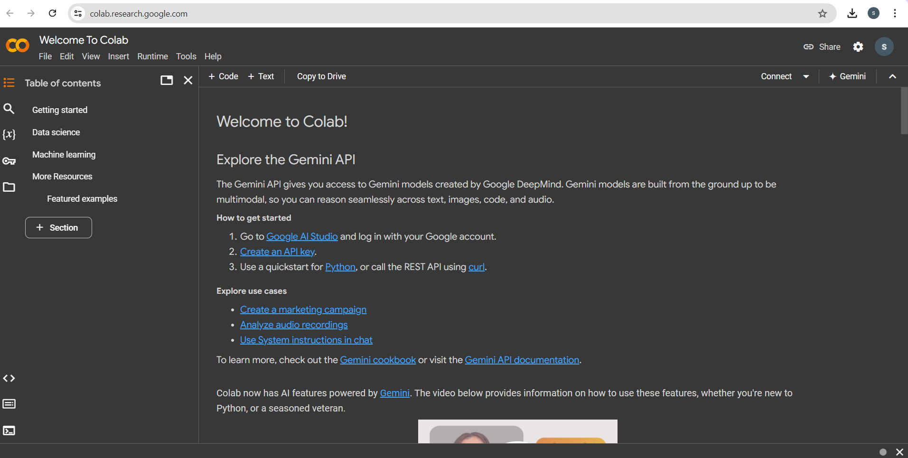

**29**

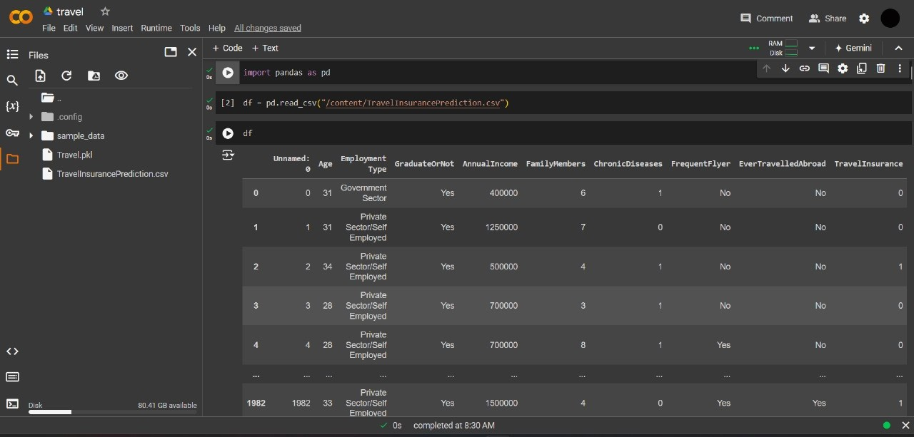

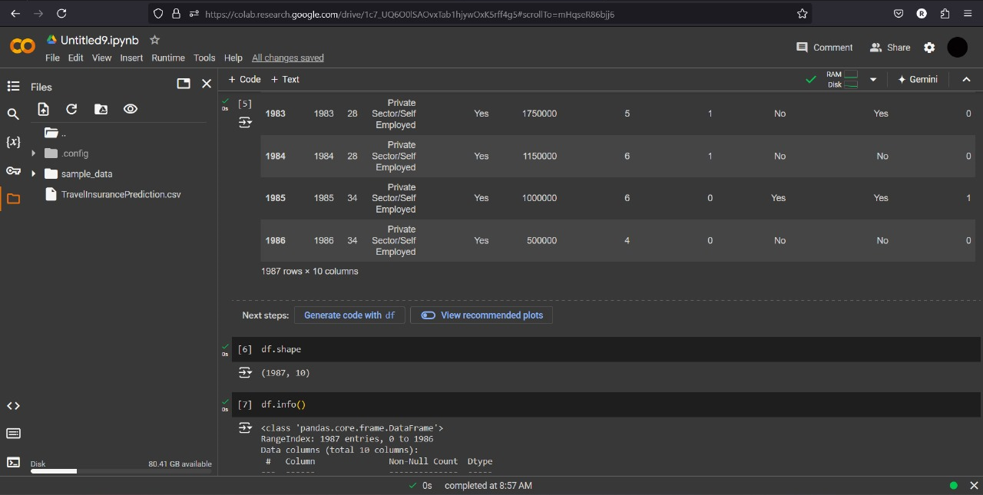

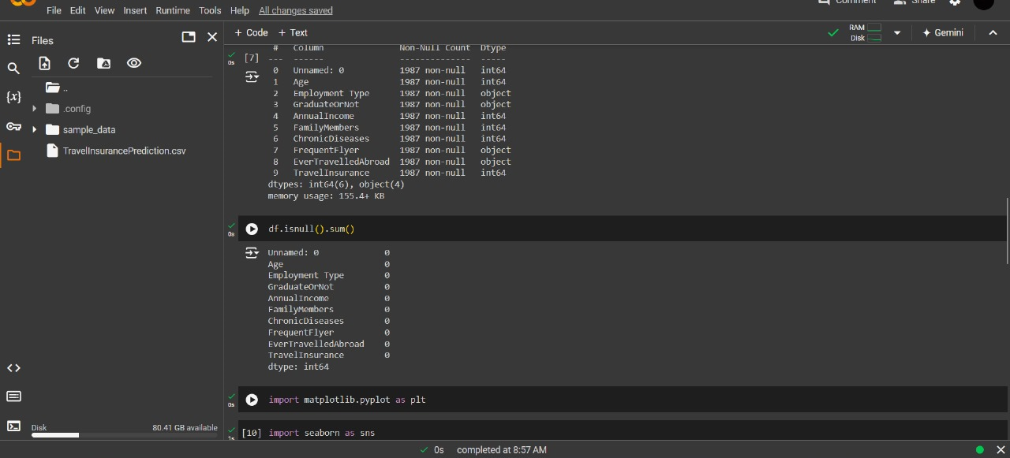

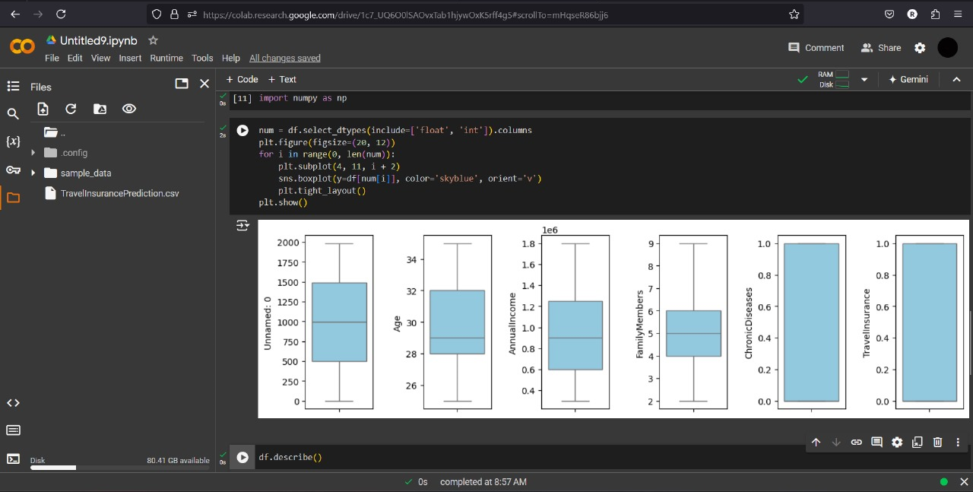

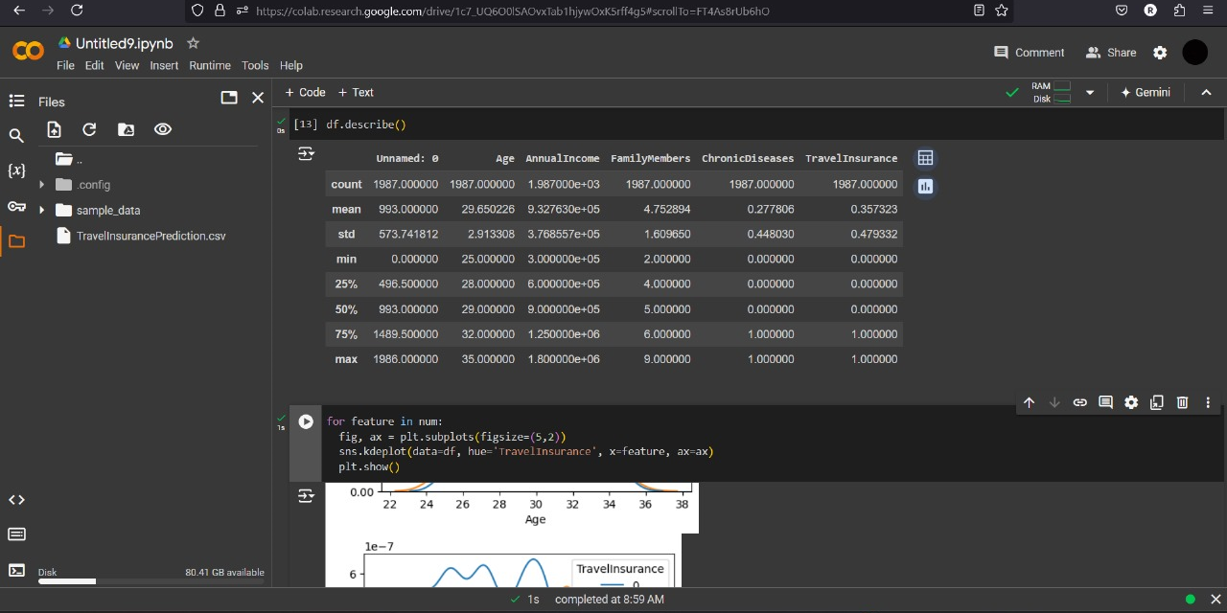

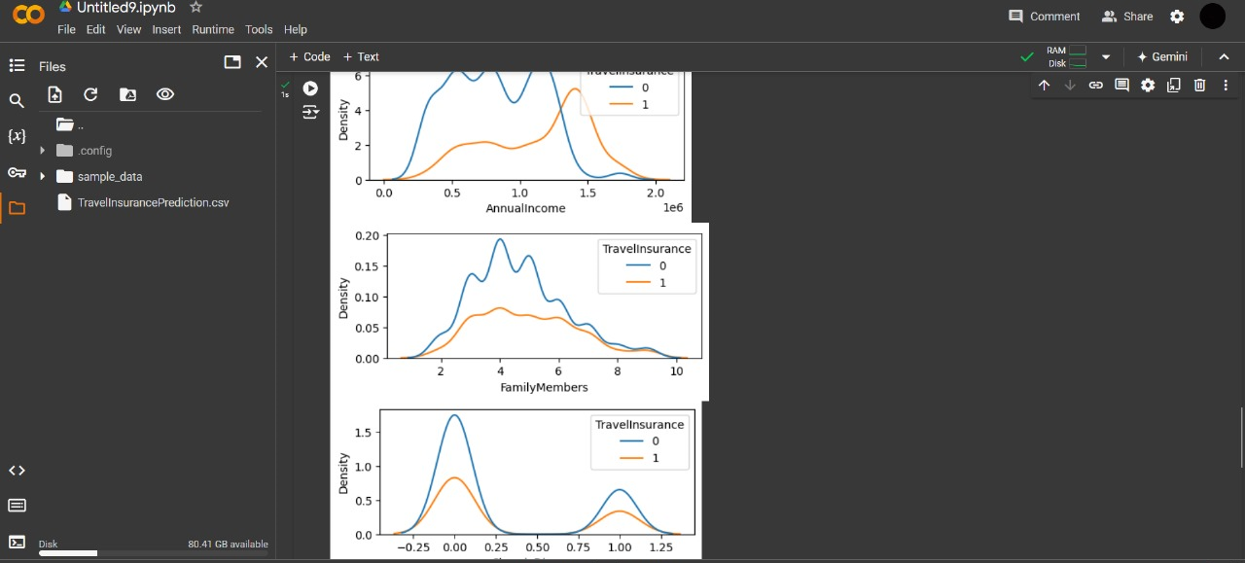

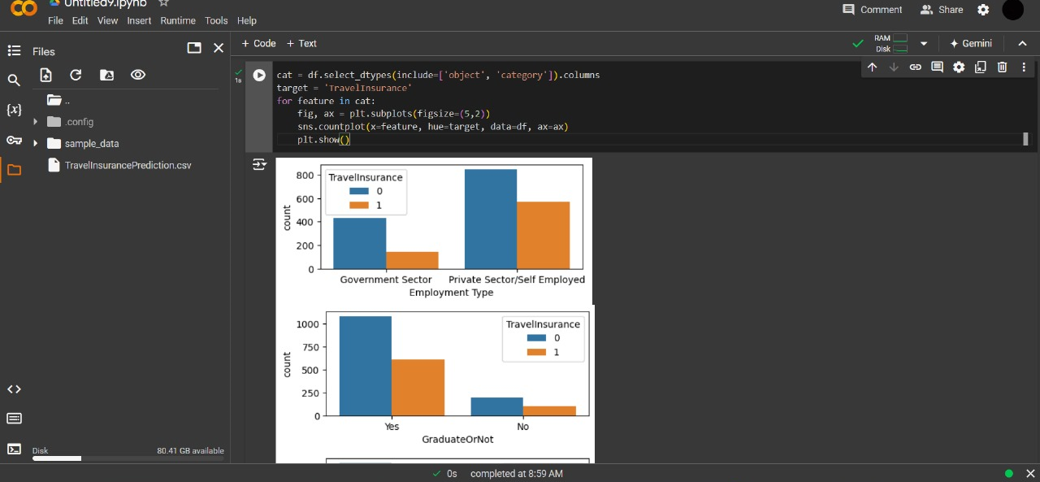

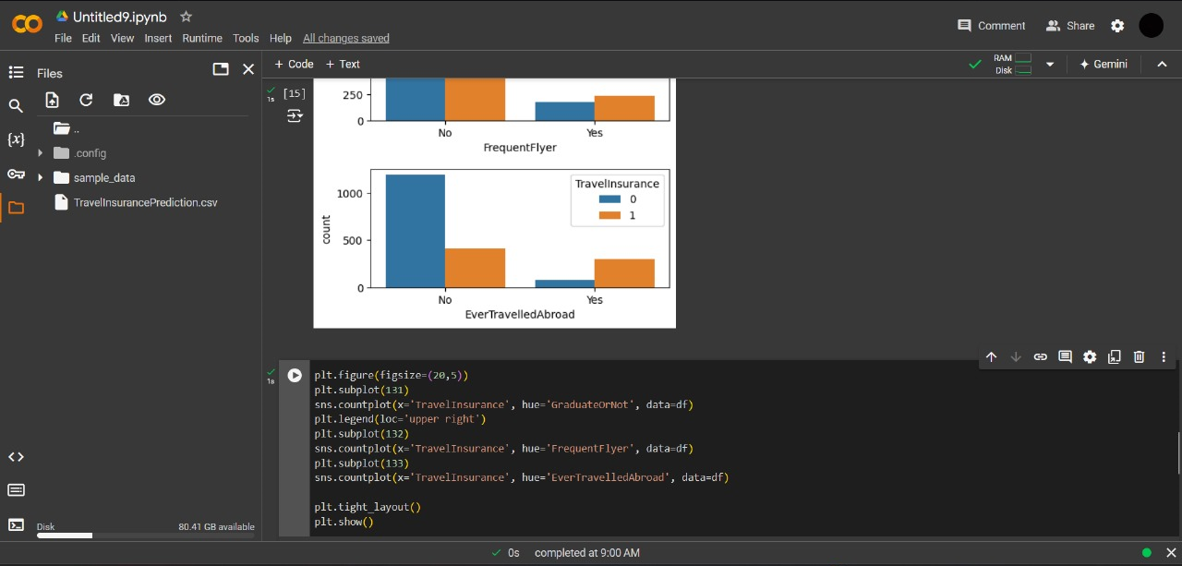

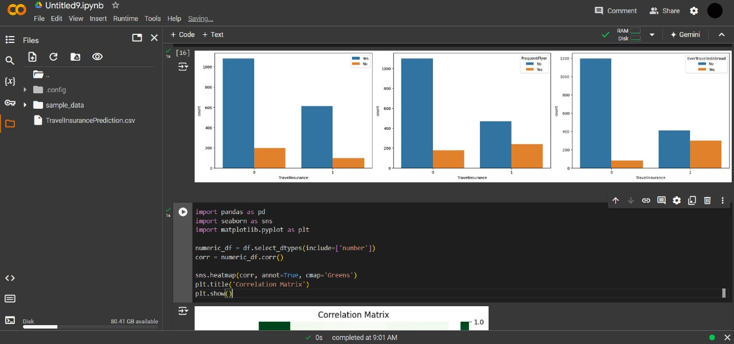

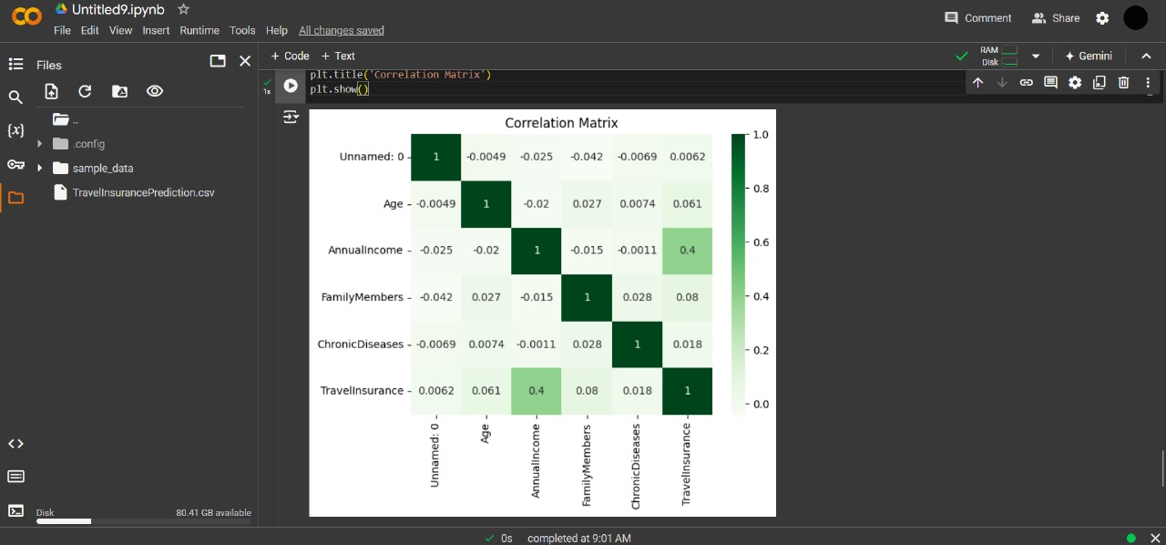

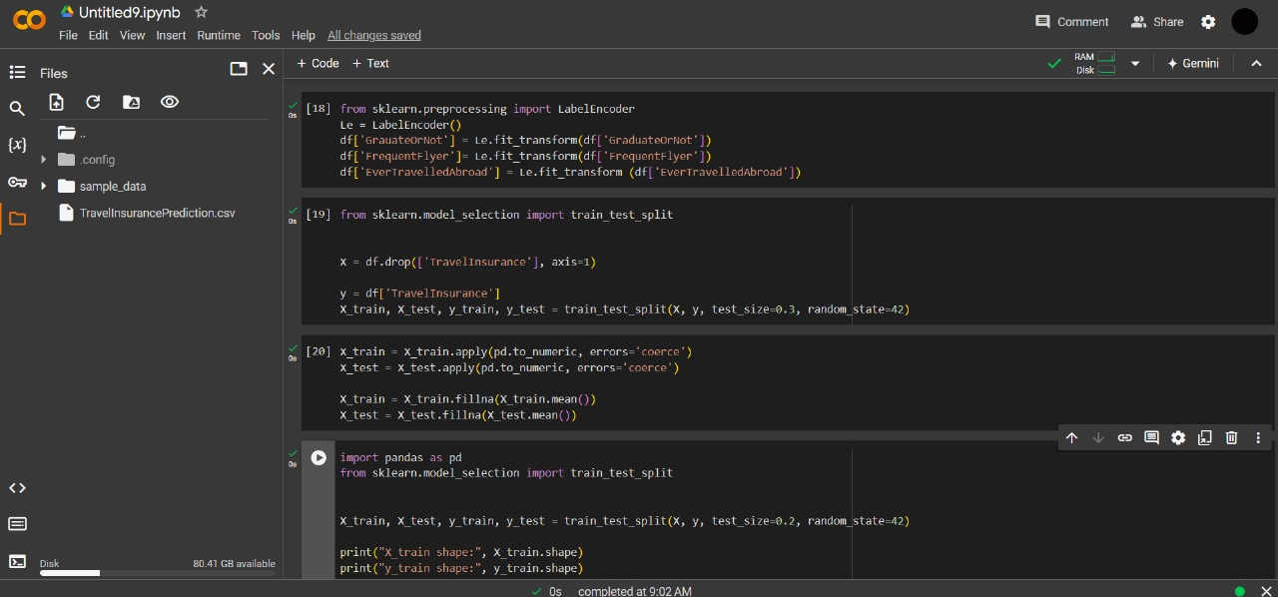

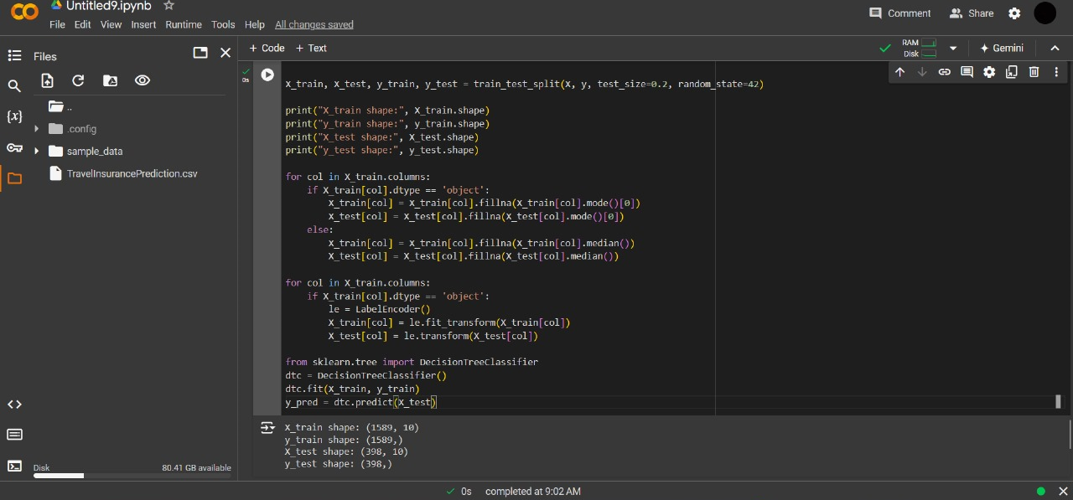

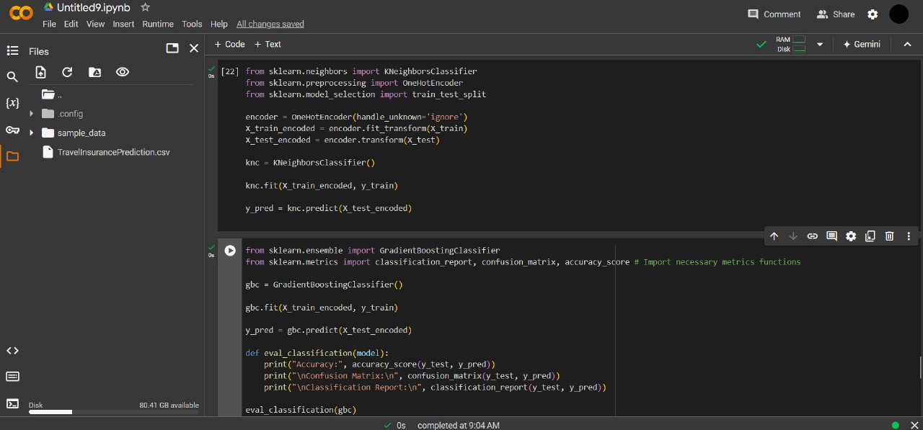

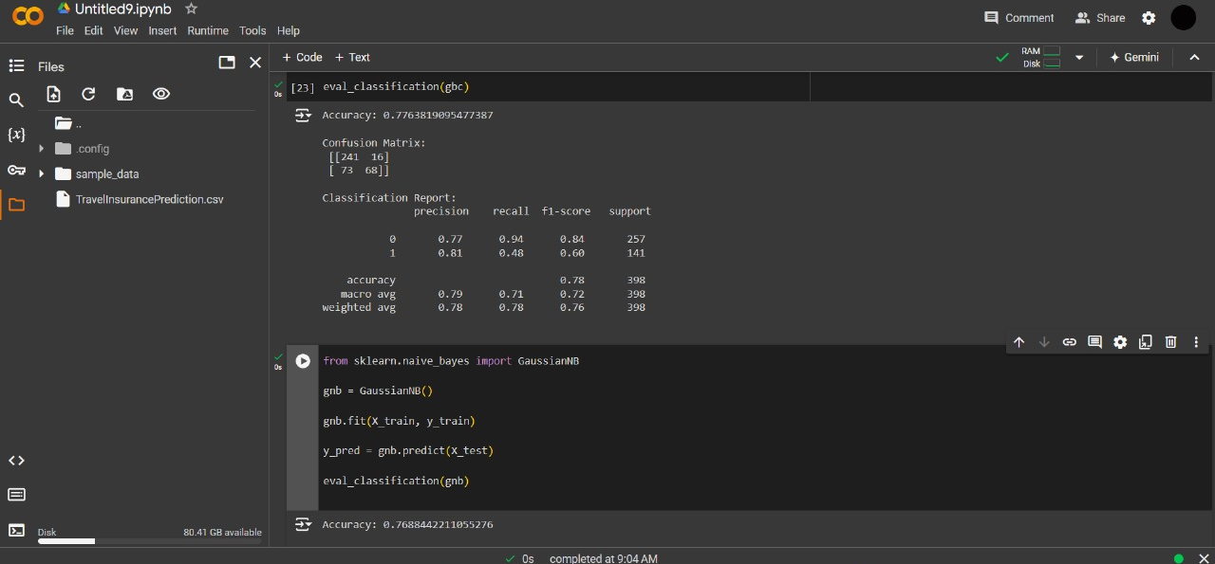

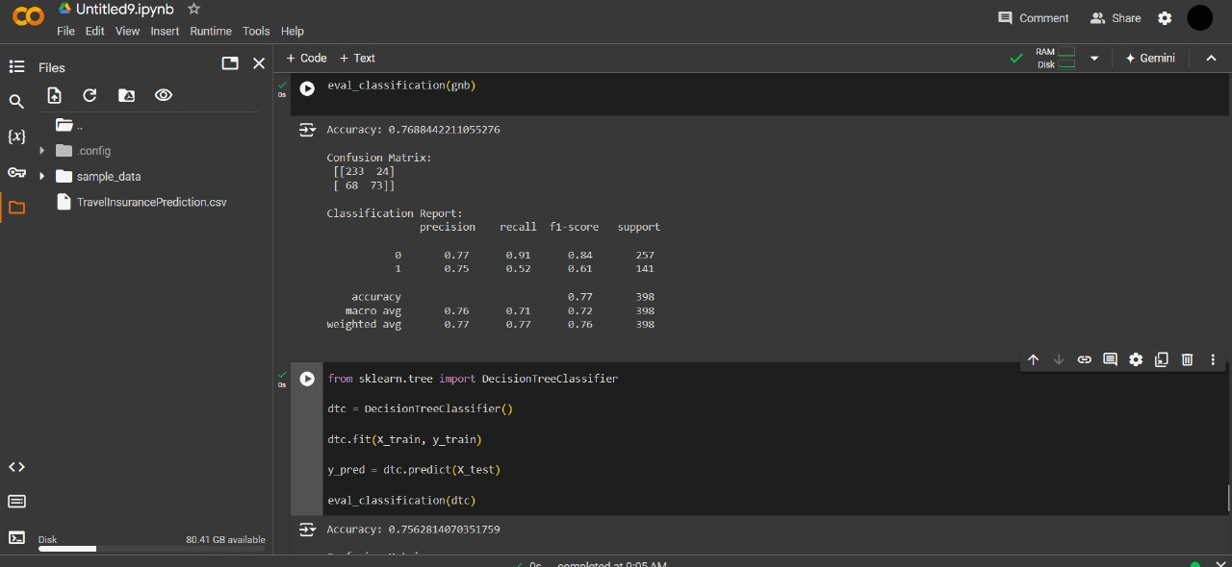

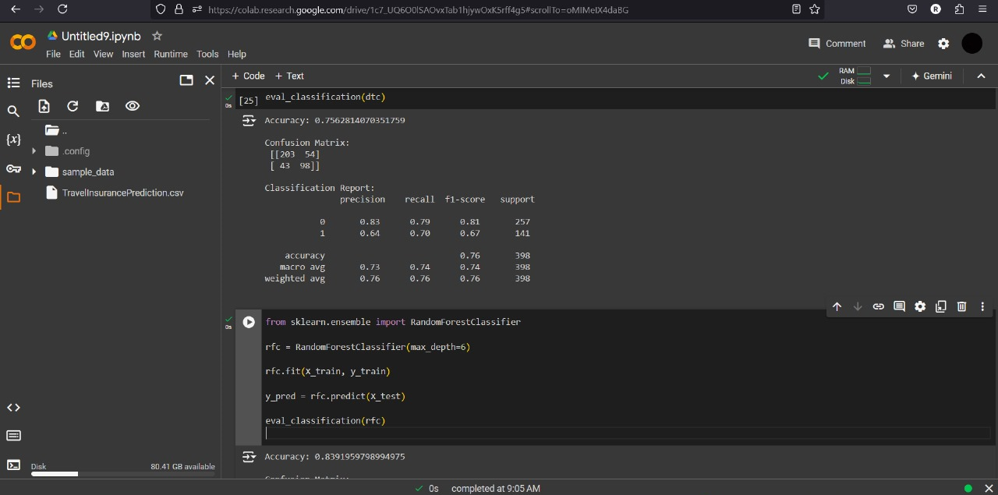

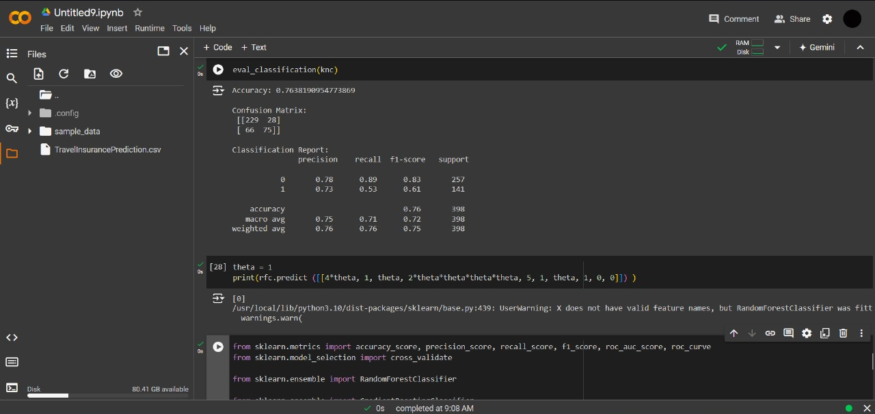

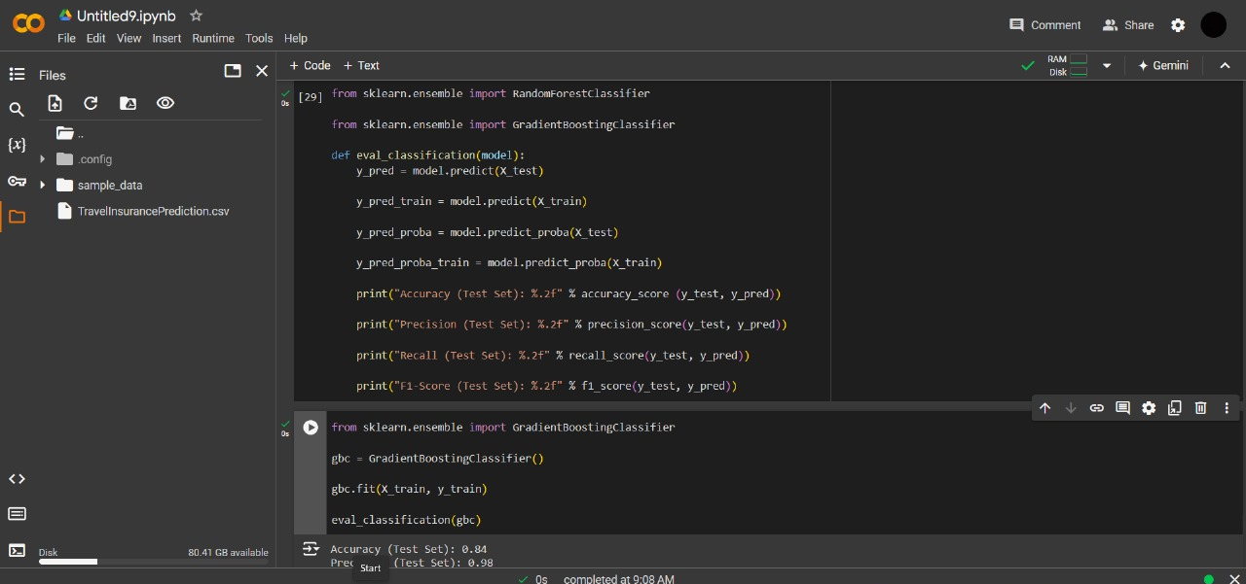

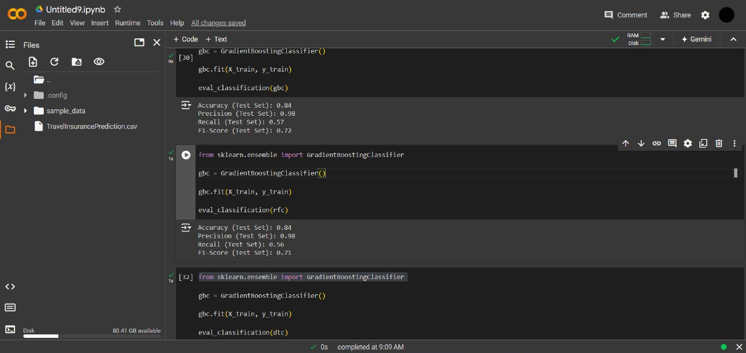

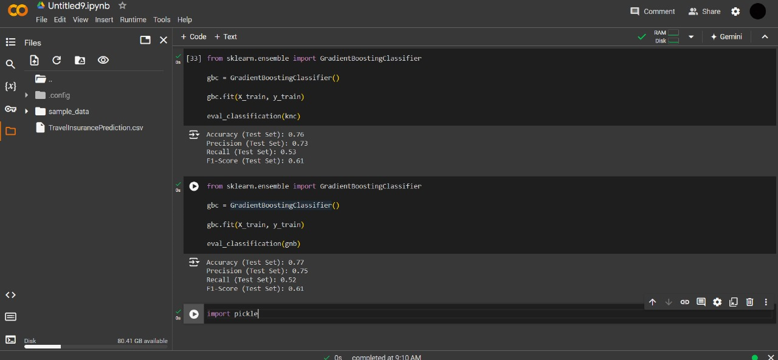

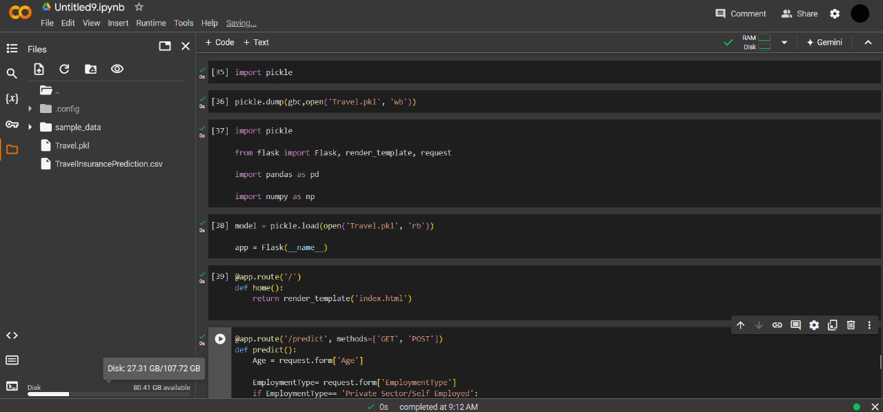

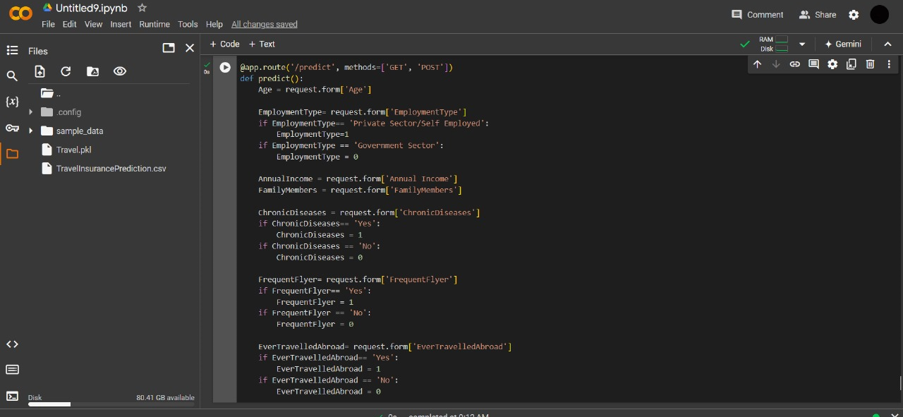

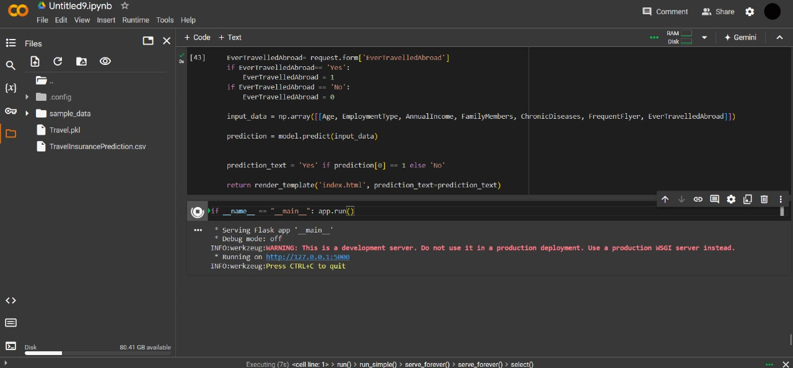

**35**